

CMPE235: Mobile Software Design

Fall 2017

Lab Assignment 2:

Smart Trees

Submitted to:

Dr. Jerry Gao

San Jose State University

Submitted by:

Pooja Shah 010828311

1 Lab Assignment Description

This assignment is designed to learn implementation of Smart Trees mobile application for different requirements. In this assignment, I chose to extend iOS based mobile application to interact with the trees. Application consists of features like registering user, sharing photos/video and music recorded file, comments along with existing functionality such as QR code reader of the tree, about, nearby business, rating of the street and many more.

Project deliverable

1. Demo : <https://youtu.be/iiDnRLY4mdE>
2. Document
3. Source Code

2 Requirements

This iOS application contains following requirements to fully cover the expected experience from client user.

2.1 Capture moments using photo and video

User can click a picture and save it as memory

2.2 User Registration

User can register in the app using manual as well as QR code. In order to register with QR, user should have QR code with details : Name, email, password, phoneno, dateofjoining

2.3 Share photo / video on social networking and mail

User can share the photo and video taken from library on Facebook , Twitter, email

2.4 Music Recording

User can record the music and share on mail, message or social platform

2.5 Comments

User can view the online comments and rate as well

3 Technologies

* Swift based application
* Interacting with APIs
* iOS AVFoundationKit for recording audio video
* Facebook and Twitter integration
* Dealing with privacy such as Photo Library, microphone etc.
* **Backend integration for Comments**
* **User registration using QRCode**

4 Design Theme

* Selected pattern
* Selected colors (Light blue and Orange combination works good for end user)
* Designed Icons
* Good interactivity within pages
* Minimum user inputs

4 Application behavior – UI Screens

1. **Launch Screen of App**

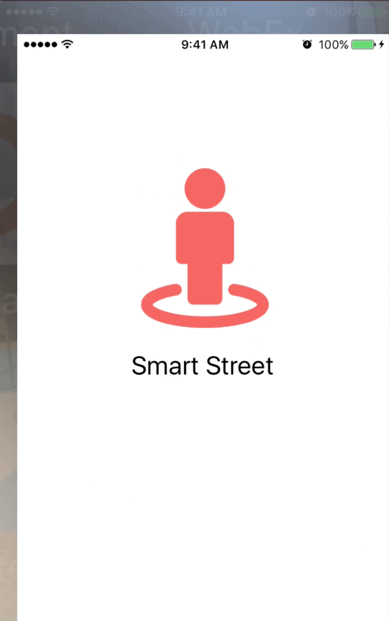

Fig 1. Launch screen

1. **User Login Page**

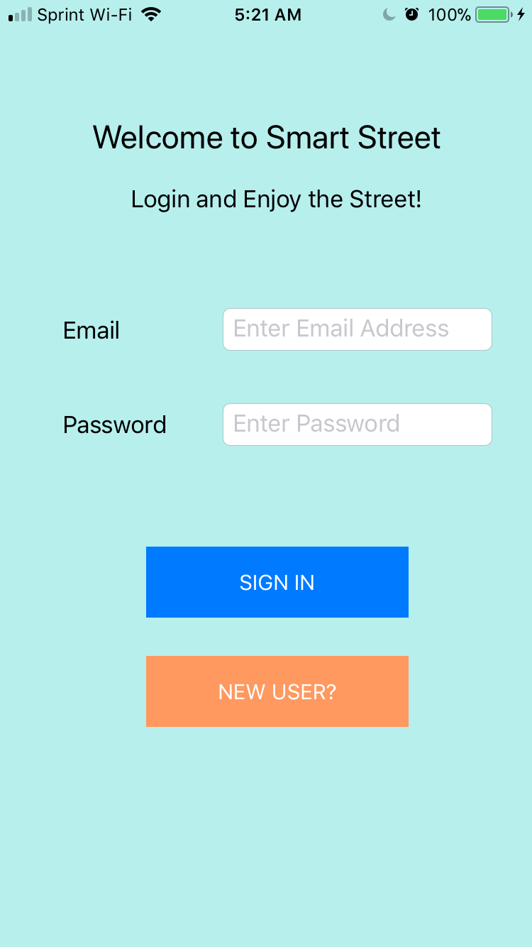

Fig 2. Login page

If user is already registered, user can login using email address and password. If not user can click on “New User?”

1. **User Registration page**

User can enter email address, name, phone, and password to create account.

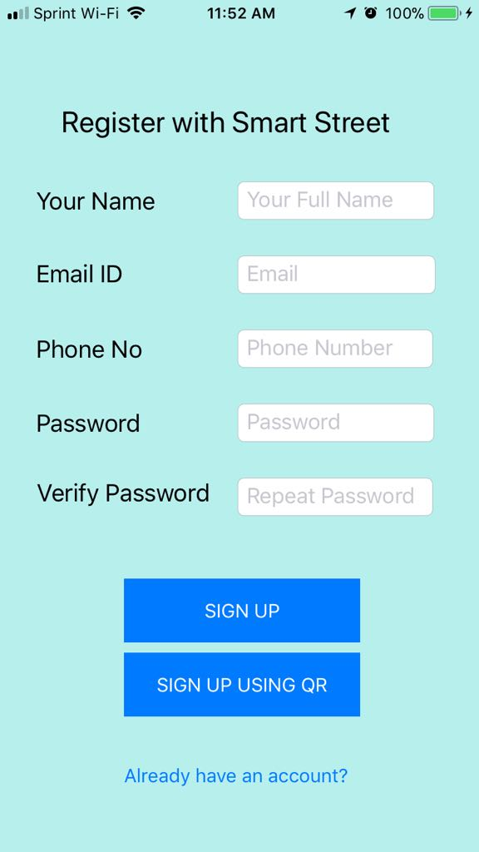

Fig 3. Signup page

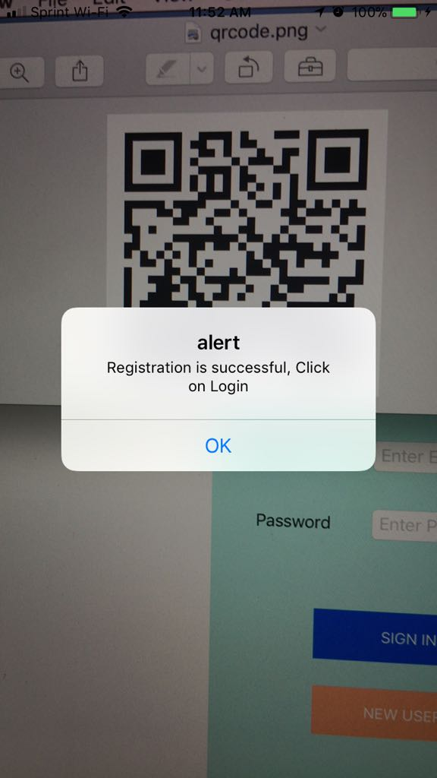

Fig Sign up using QRCode

1. **Validations for user registration**

User may encounter in authentication validations as shown in Fig 4 and Fig 5

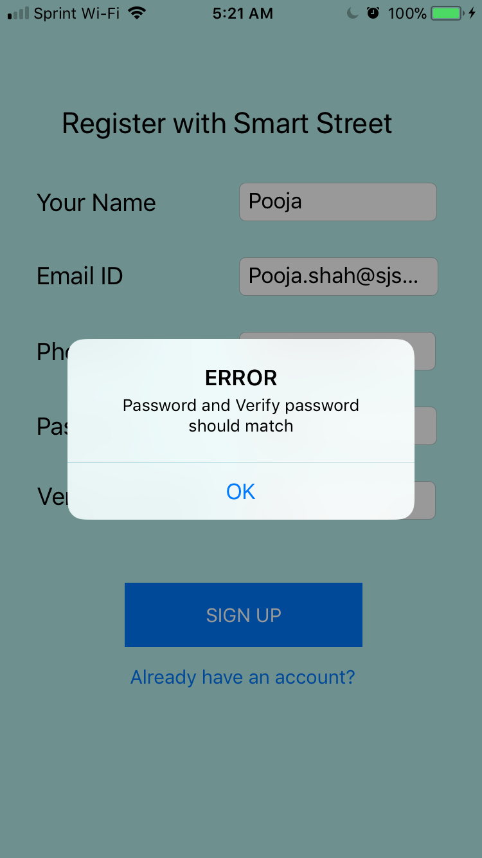

**Fig 4. shows Password and verify password did not match while registering**

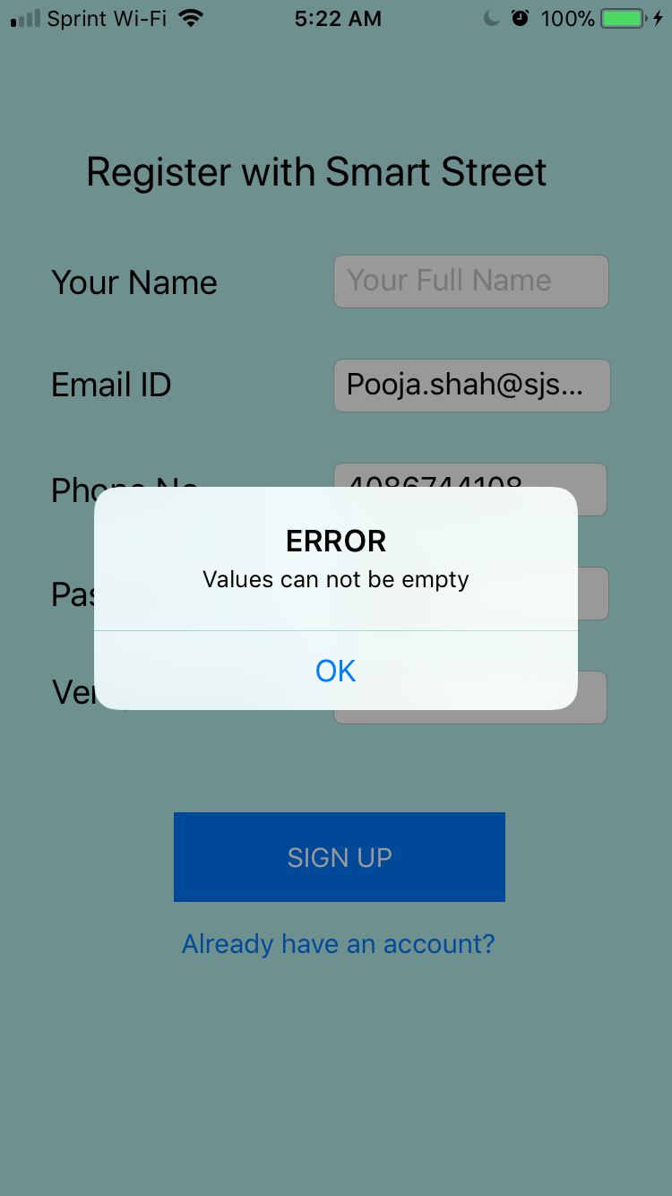

Fig 5. User did not complete the registration form

1. **Successful Registration**

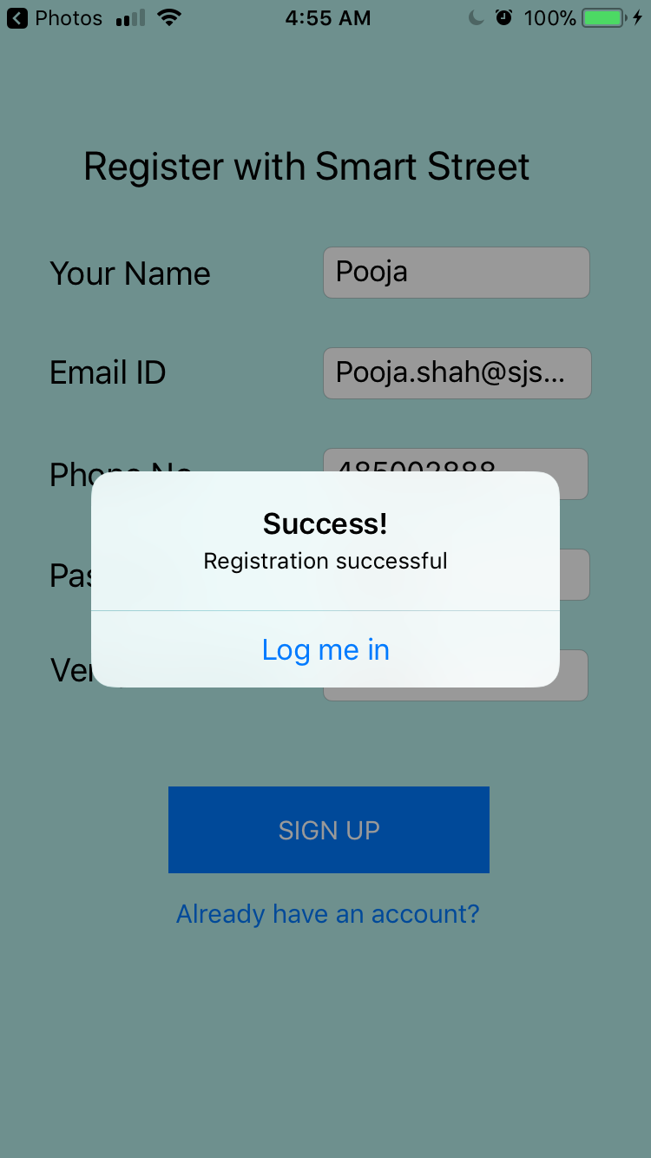

Fig 6. User can now login

1. **Side bar menu for easy access to profile**

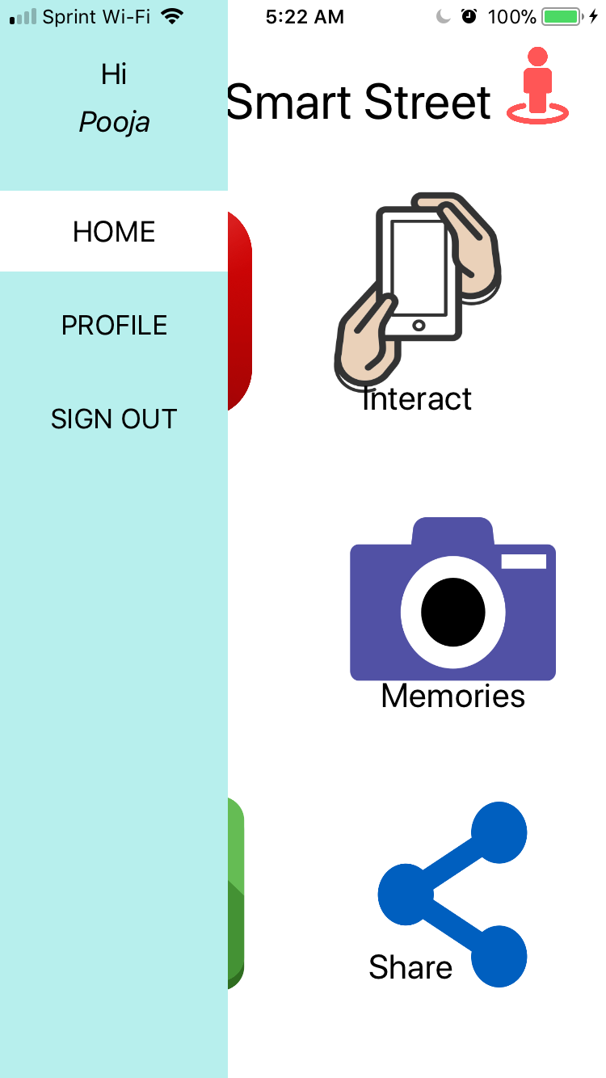

Fig 7. Sign out and profile access from root view

1. **Collapsible Menu**

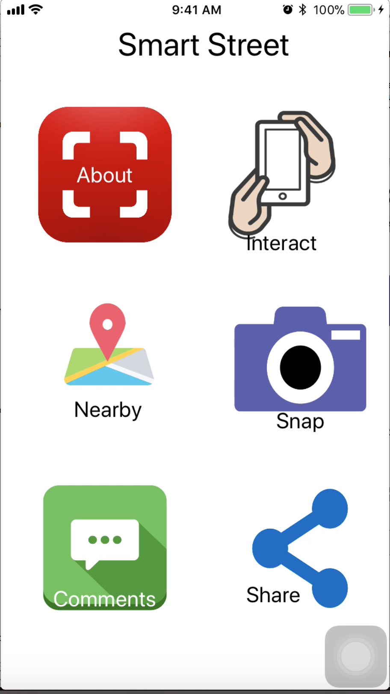

Fig 8. Sidebar collapsed after clicking on button

1. **Scanning QR Code as shown in fig 9**

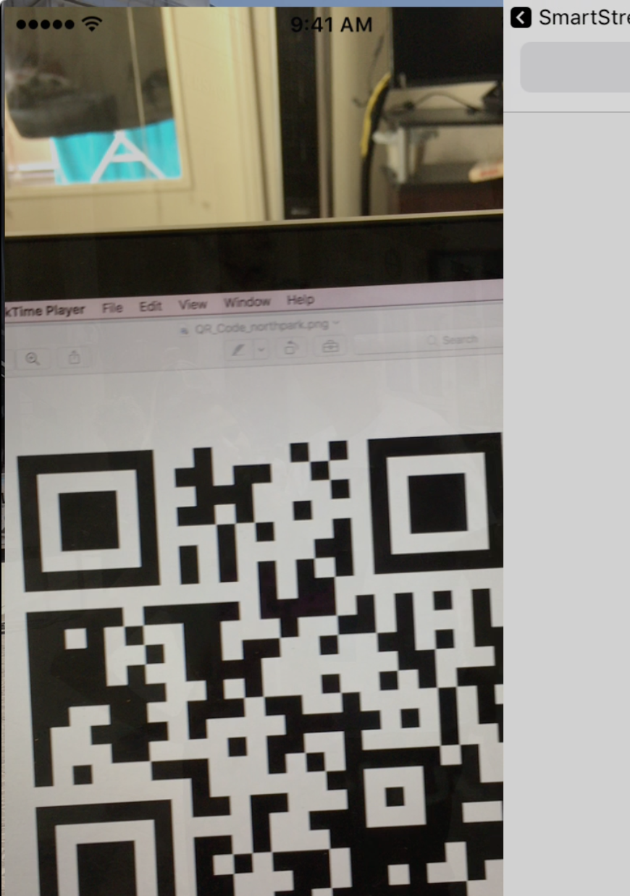

Fig 9. Scanning QR

1. **Fig 10 shows Corresponding details of the tree will be displayed on URL linked to the QR code**

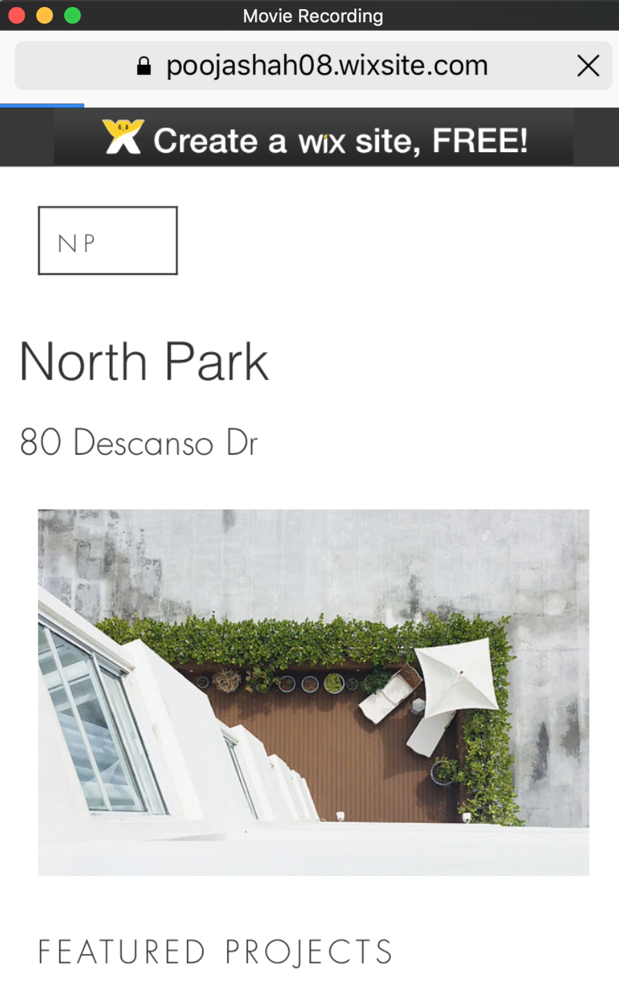

Fig 10. Interaction with Tree

1. **Fig 11 shows the Profile page of user**



Fig 11. Profile Page

1. **As shown in Fig 12, you can Capture Memories using Photo/Video or even Record music playing around and share**

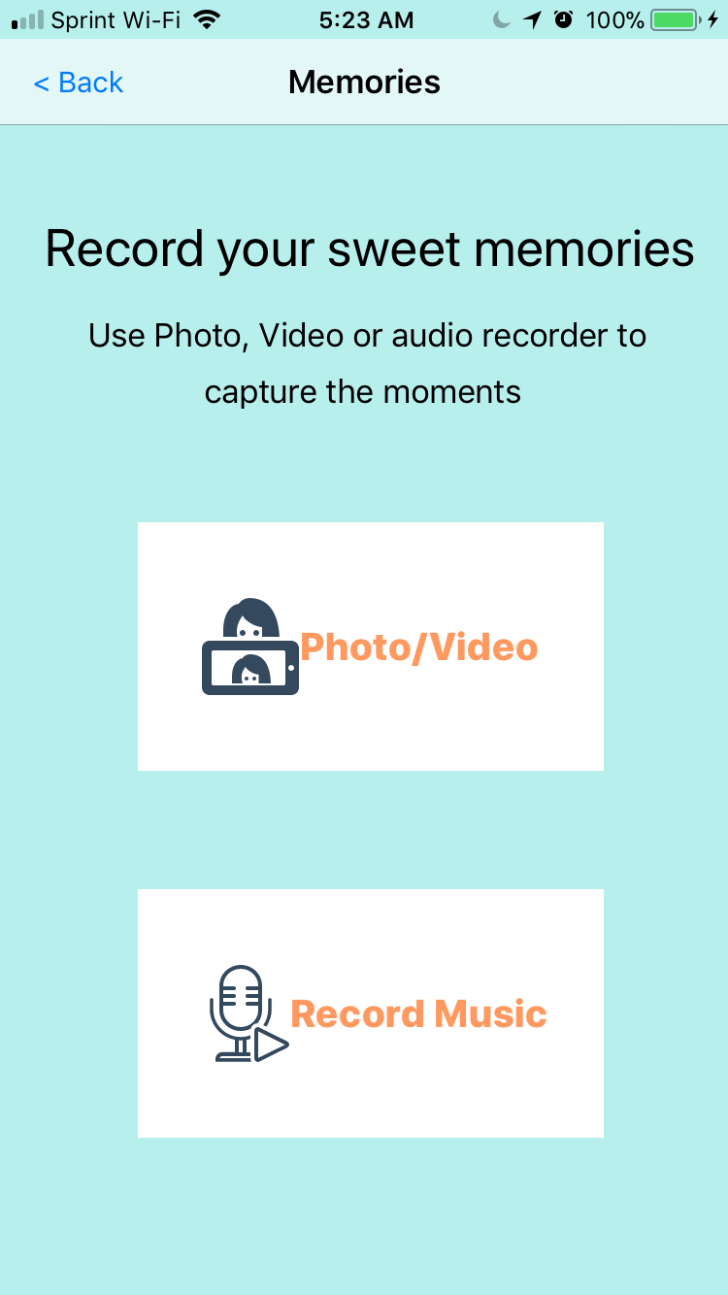

Fig 12. Take photo, video and record audio

1. **As shown in Fig 13, after users clicks on Photo or Video, user can use camera to capture photo or video and use photo to save in library**



Fig 13. Preview of clicked Photo

1. **User can Record Music by clicking on microphone button, also click on share to share.**

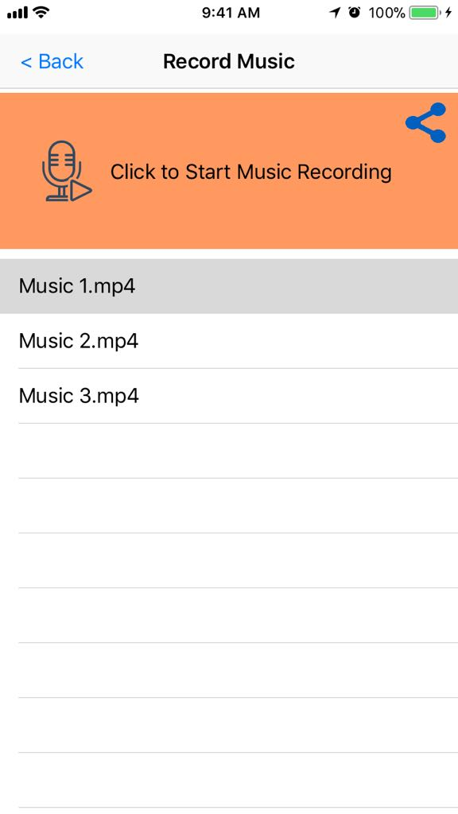

Fig 14. Recorded Audios

**Music SHARE : User has variety of menu options to share music**

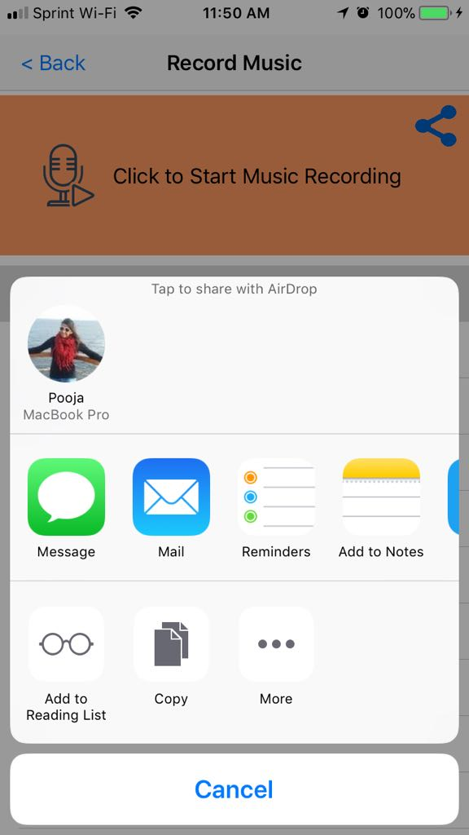

Fig 15. SHARE MENU

As showin in fig 16, recording will be attached in mp4 format

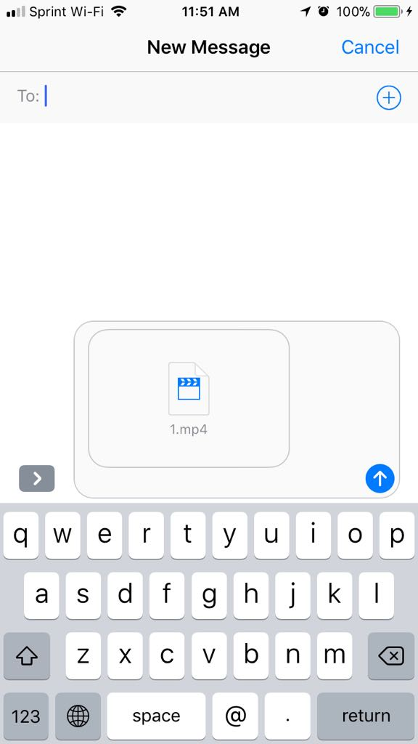

1. Share music on message
2. **User can share photos and videos with twitter, facebook and email**

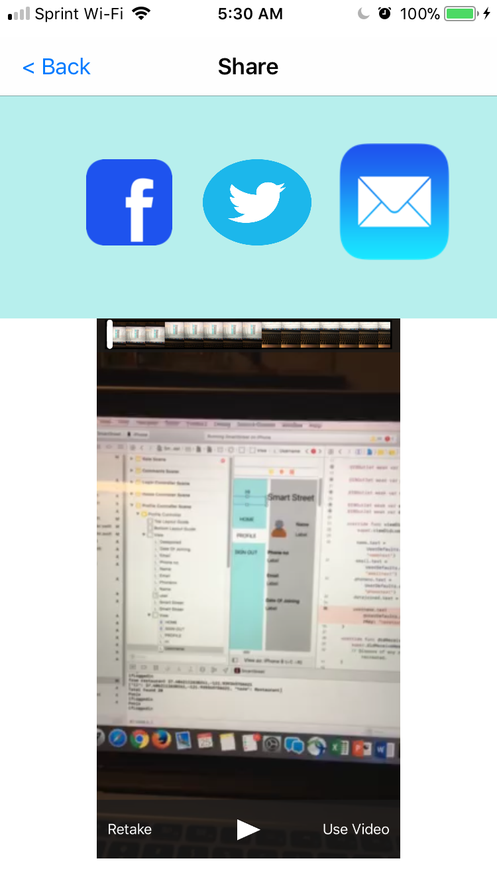

Fig 17. Share photo on Facebook (phot/video)

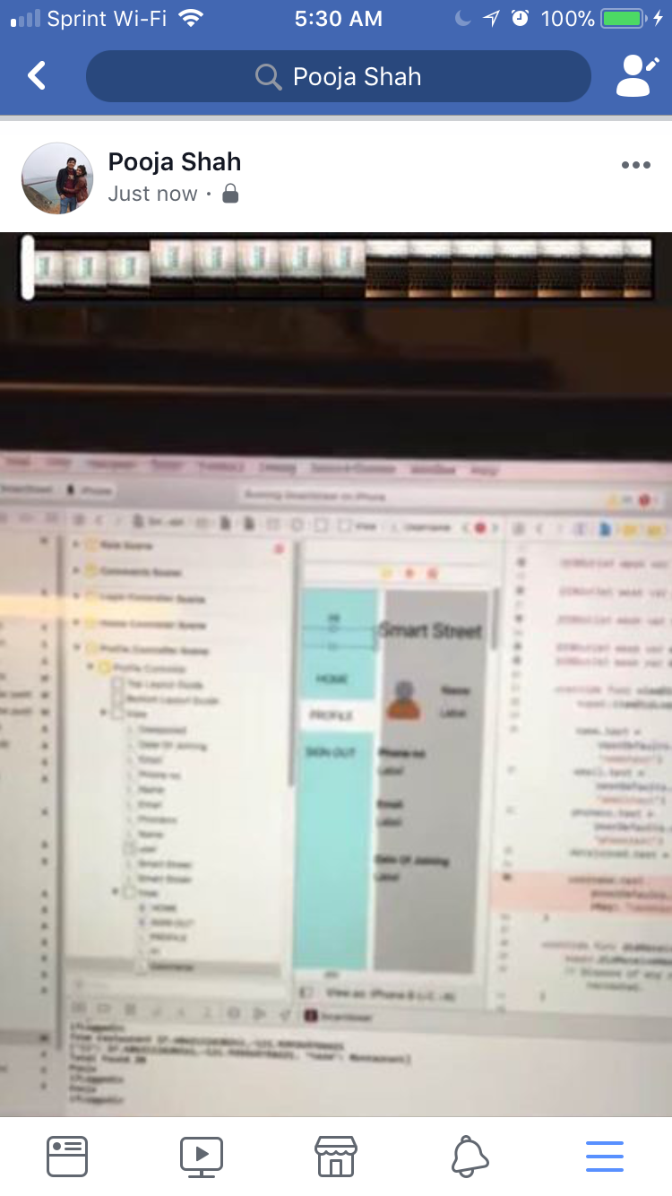

Fig 18. Photo shared on Facebook

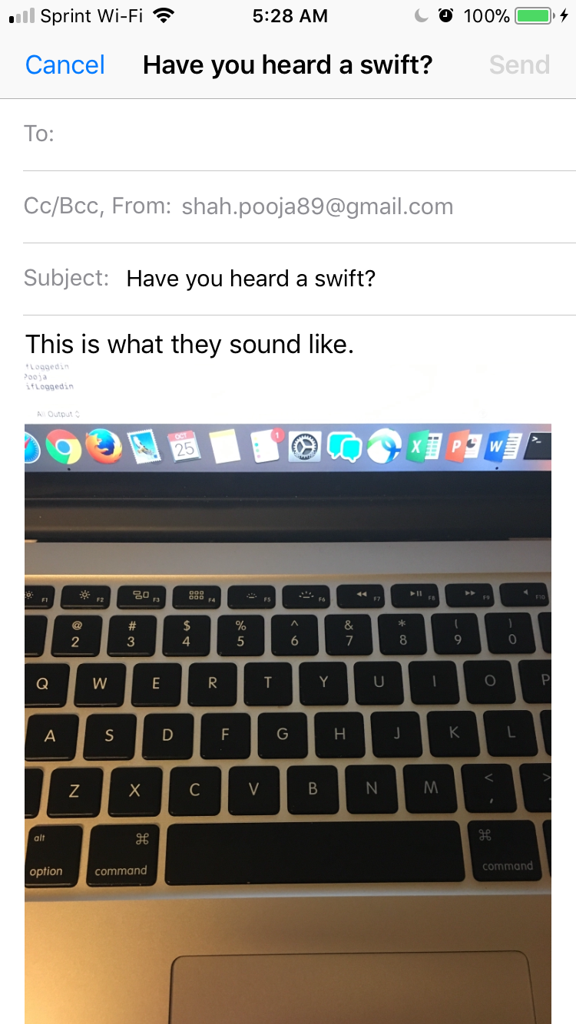

Fig 19. Share on Email

1. You can view Comments and Ratings

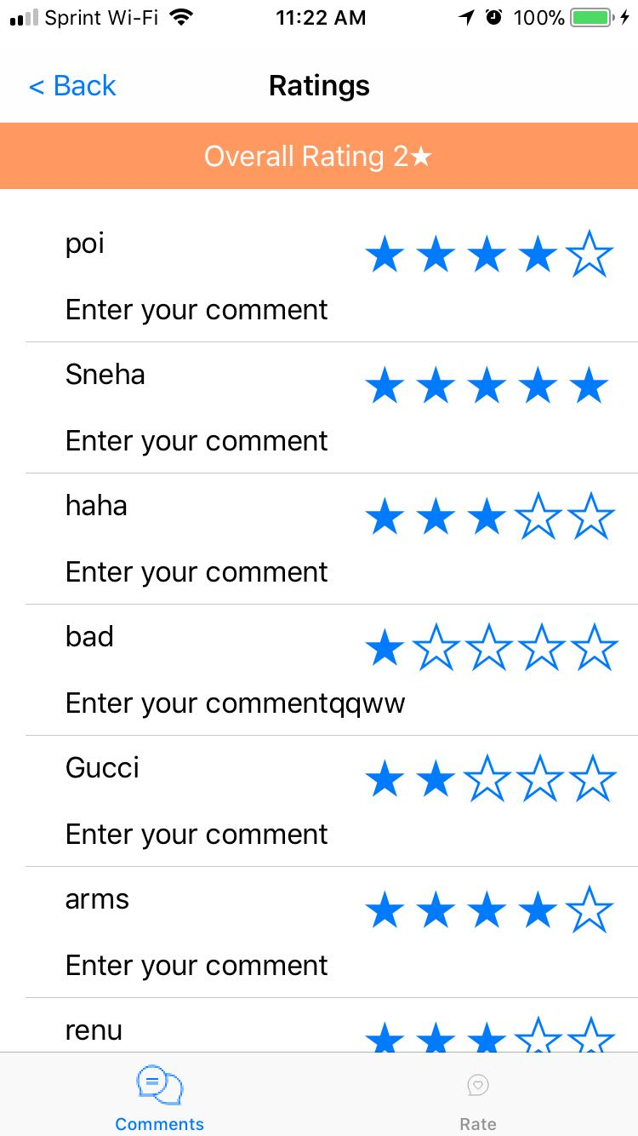

Fig 20. Comments

‘

1. You can post your comment and give rating as shown in Fig 21, 22 and 23

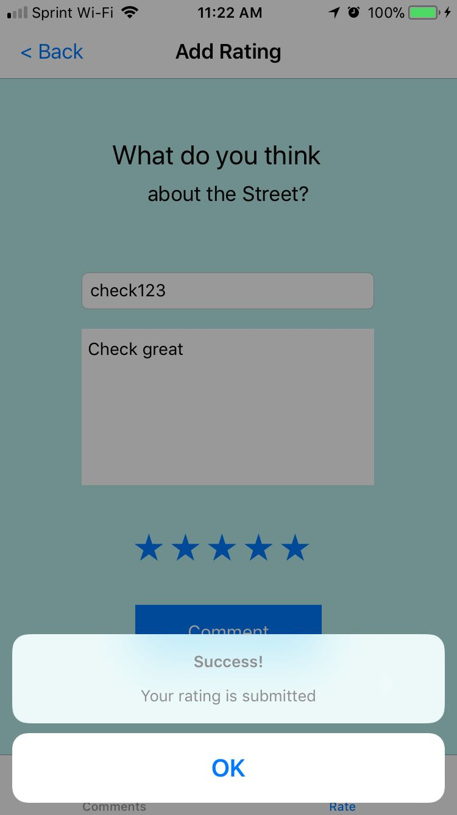

Fig 21. Post comment

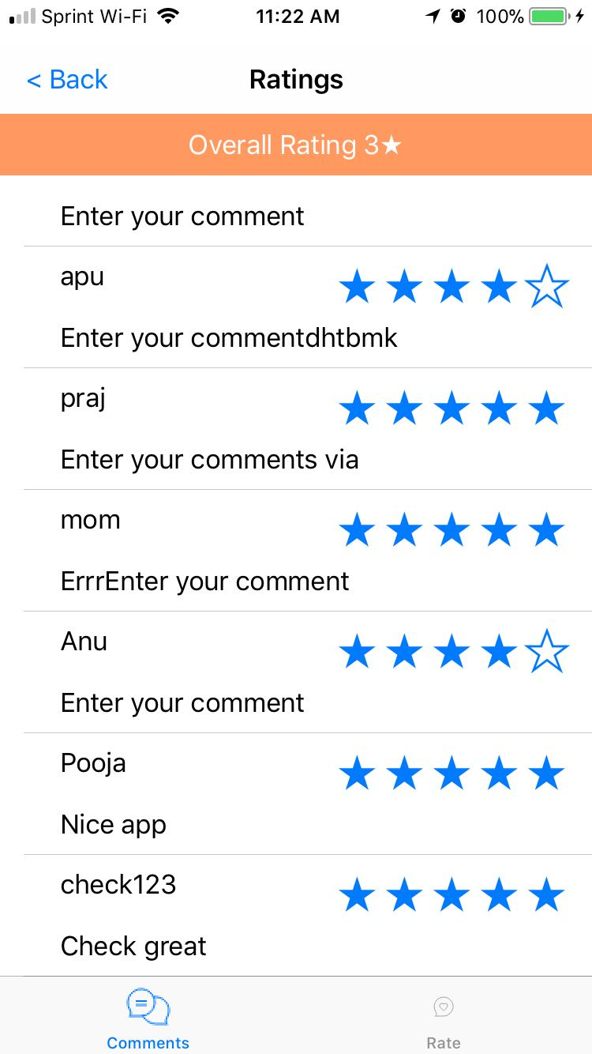

Fig 22. After adding comment

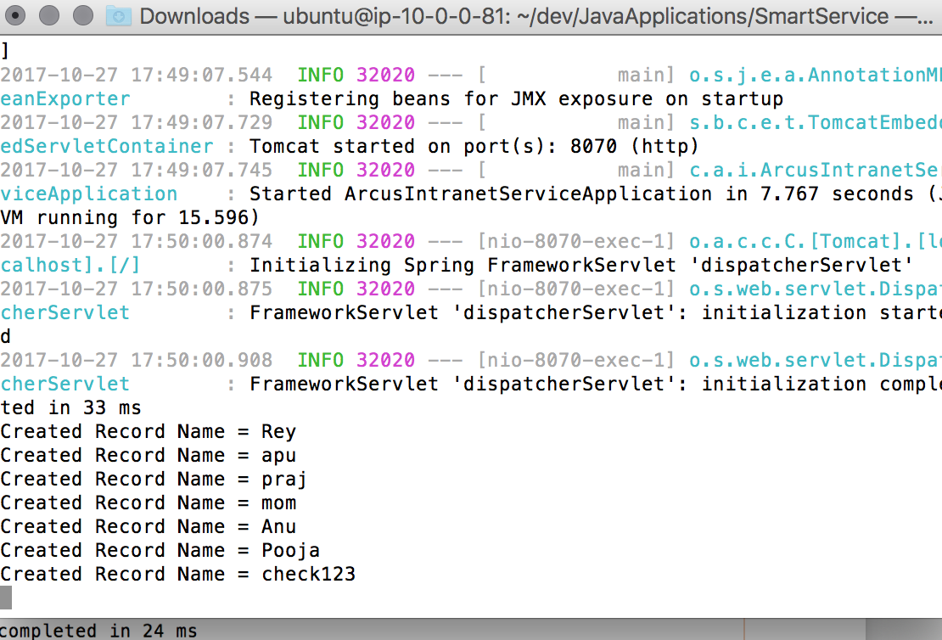

Fig 23. Back end server for generating comments

4 Conclusion

Successfully completed the Smart Street mobile application using iOS Swift.